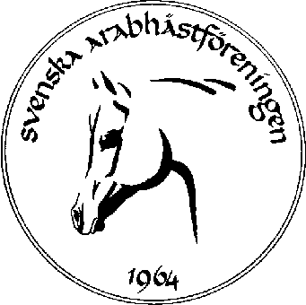 CHAMPIONS AND BEST-IN-SHOW

SAHF´s Riksutställning - Swedish National Show

Blommeröd, Sweden

31 juli/July-1 augusti/August 2004

________________________________________________________________
Champion Reserve Champion
H.K.H. Princess Alia Al Hussein Al Saleh, Jordanien 25 23
Mr. Peter Upton, Great Britain 16 6
Mr. Sheik Hamad Bin Ali Al Thani, Qatar 25 25
Mr. Jörgen Frederiksen, Denmark 16 6

Junior Female Champion: (16) JB FFEMME FFATAL
Reserve Junior Female Champion: (6) MIGRACJA

________________________________________________________________
Champion Reserve Champion
H.K.H. Princess Alia Al Hussein Al Saleh, Jordanien 46 35
Mr. Peter Upton, Great Britain 39 39
Mr. Sheik Hamad Bin Ali Al Thani, Qatar 46 39
Mr. Jörgen Frederiksen, Denmark 39 39

Junior Stallion Champion: (46) MAMBO
Reserve Junior Stallion Champion: (39) DONBULL

________________________________________________________________
Champion Reserve Champion
H.K.H. Princess Alia Al Hussein Al Saleh, Jordanien 77 76
Mr. Peter Upton, Great Britain 77 76
Mr. Sheik Hamad Bin Ali Al Thani, Qatar 77 76
Mr. Jörgen Frederiksen, Denmark 77 76

Senior Female Champion: (77) EWAKUACJA PL
Reserve Senior Female Champion: (76) SZANSA

________________________________________________________________
Champion Reserve Champion
H.K.H. Princess Alia Al Hussein Al Saleh, Jordanien 93 84
Mr. Peter Upton, Great Britain 93 84
Mr. Sheik Hamad Bin Ali Al Thani, Qatar 97 97
Mr. Jörgen Frederiksen, Denmark 93 97

Senior Male Champion: (93) OM EL TANAM US
Reserve Senior Male Champion: (97) MEDALJ

________________________________________________________________

BEST-IN-SHOW: EWAKUACJA PL

________________________________________________________________

